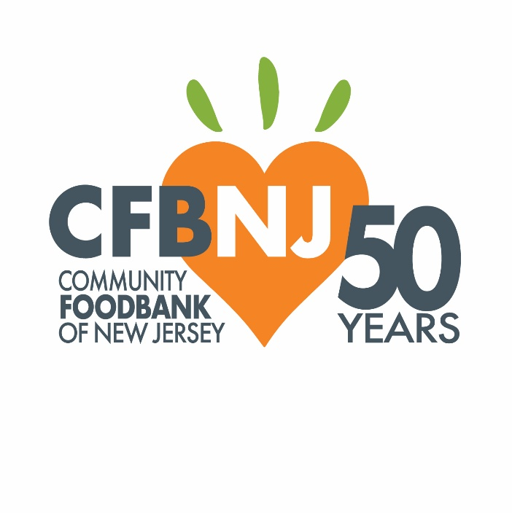

**FY25 Agricultural Innovation Grant Program**

**Application Questions**

# **ONLINE APPLICATION PREVIEW**

*NOTE: The purpose of this document is to share the application questions and requirements so that you may work online and/or collaboratively prior to submitting through Survey Monkey Apply.*

# **SECTION ONE: GENERAL INFORMATION FORM**

# This section covers general information about your business or organization and the person submitting this application.

# This application will have three sections:

* Section One: General Information
* Section Two: Proposal Request
* Section Three: Budget

## Please confirm that you understand all the components of the application.

* I read the summary above.

**BACKGROUND INFORMATION**

**PAGE 1**

**What type of organization/entity do you represent? Please check all that apply.**

* For-profit business
* Nonprofit organization
* Educational institution
* Processor
* Aggregator
* Other

**Contact Information**

For "Business or Organization Name" please provide the name exactly as it appears on your Form W-9. Should your organization be awarded a grant, the accuracy of this information will allow CFBNJ to ensure prompt disbursement of funds.

**(***NOTE: In the online application each of these questions will include a text field where this data should go.***)**

Email*

Website/Social Media Address*

Phone Number*

First Name*

Last Name*

Farm Name*

Mailing Address*

Farm/Business/Organization Address*

EIN Number/Tax ID Number*

**What is the best way to contact you should there be questions about your application? \***

* Email
* Phone

**In which county is your business or organization located? (check box with all counties)**

* Atlantic
* Bergen
* Cape May
* Cumberland
* Essex
* Hudson
* Hunterdon
* Mercer
* Middlesex
* Morris
* Passaic
* Somerset
* Sussex
* Union
* Warren

**Which county or counties does your business or nonprofit serve? Please note that while this grant opportunity is open exclusively to for-profit businesses or nonprofit organizations located in the 15 counties noted in the previous questions, it is understood that applicants may provide services in additional counties.**

**Please check all that apply.**

* Atlantic
* Bergen
* Burlington
* Cape May
* Camden
* Cumberland
* Essex
* Gloucester
* Hudson
* Hunterdon
* Mercer
* Middlesex
* Monmouth
* Morris
* Ocean
* Passaic
* Salem
* Somerset
* Sussex
* Union
* Warren

**What type of farm do you have? Please select all that apply:**

* Diversified
* Produce
* Dairy
* Livestock
* Other (please specify below)
* Not applicable

**PAGE 2**

**How long has your farm been in operation?**

* 1-3 years
* 4-10 years
* 10+ years
* Not applicable (I do not represent a farm)

**What is the size of your farm actively cultivated or used for pastureland?**

* Less than one acre
* 1-9 acres
* 10-25 acres
* 26 to 100 acres
* 101 to 500 acres
* 500+ acres
* Not applicable (I do not represent a farm)

**What goods or services does your business or organization provide?** *(Recommended maximum word count: 100 words)*

**Do you own or lease farmland? \***

* Own
* Lease*
* Not applicable (I do not represent a farm)

**If your current lease expires before July 1, 2028, please explain how your land tenure/security is sufficient in relation to the improvements being made or purchased.** *(Recommended maximum word count: 250 words)*

**Please upload proof of ownership or secure land access (lease agreement). (upload)**

**Do you understand that your farm or organization must agree to maintain ownership and primary use of items purchased using grant funds for at least three (3) years following the grant award?**

* Yes
* No

*Observation: should you select “no” the application process will come to an end as this is a requirement.*

**PAGE 3**

**For nonprofit organizations only - Please upload your IRS Determination Letter**

The 501(c)(3) determination letter is a legal document issued by the IRS. It proves an organization has federal tax-exempt status. After the organization applies for tax exemption under Section 501(c)(3) of the tax code, the IRS responds to the organization with a “determination letter of approval.” Organizations that are part of a larger, often regional or national organization, such as faith-based partners, must submit the IRS Determination Letter of their larger, central organization.

**File upload***(Please upload this standard document from your computer where indicated)*

**For both nonprofit and for-project applicants - Please upload your Form W-9 (required of all applicants)**

The Form W-9 is an IRS tax form used to confirm specific identification information, such as the applicant organization’s EIN, organization name, and address, and is certified with a signature by the responsible person in the organization. CFBNJ requires the W-9 to distribute money awarded to each grantee.

**File upload***(Please upload this standard document from your computer where indicated)*

**SECTION TWO: FUNDING REQUEST**

**Total Funding Requested – Please enter an amount between $2,500 and $25,000**

**Please share a narrative description of how you plan to use funding, if awarded. Please clearly describe your project, and in 2-3 paragraphs how it will contribute to the resilience of your farm and/or community. What do you hope to accomplish with this grant that you otherwise would not have been able to? *(Recommended maximum word count: 300 words)***

**Is there anything else you would like to share that relates to this submission?**

**SECTION THREE: BUDGET**

**Please download and complete the budget template, clearly detailing how you will use the awarded funds.**

**Upload budget spreadsheet (if applicable)**

**Are there additional sources of funding you are seeking to support the implementation of this project? (Matching funds, additional grants, etc.)**

* Yes
* No

**If CFBNJ is unable to fully fund your grant request, would you be able to obtain additional funding elsewhere, or modify the program/project so that it can still move forward?**

* Yes
* No. If it is decided our grant request cannot be fully funded as outlined in our proposal, we wish to NOT be considered for funding at this time.

**CFBNJ Vendor Selection Form**

As outlined in the Grant Notice, individual items above $10,000 in cost will require presentation of three (3) cost quotes from three different vendors as completion of CFBNJ's vendor selection form.

**Click** [**here**](https://cfbnj.smapply.io/protected/nr/T6MsN/CFBNJ_Vendor_Selection_Form_Blank.pdf) to open the vendor selection form. Please download the document and upload it when completed.

*NOTE: Please click “here” to open this form, which will open in a new tab in your browser.*

Uploads

CFBNJ vendor selection form

Quote

Quote

Quote