Corn Salad
Preparation: 10 minutes
Serves: 6
Ingredients:
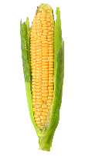 2 cups corn cooked
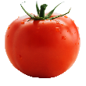 1 ½ cups tomatoes diced
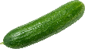 1 cup cucumber peeled and diced
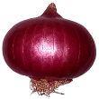 ½ cup red onion finely chopped (about ½ onion)
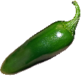 1 jalapeno pepper seeded and finely chopped
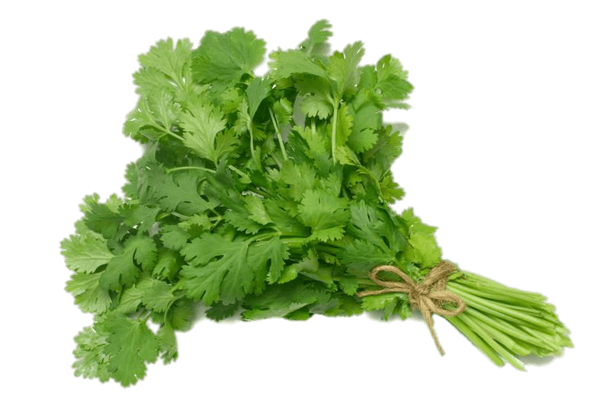 ½ cup fresh cilantro cut and discard bottom 2 inches of stems, chopped
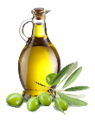 2 teaspoons olive oil
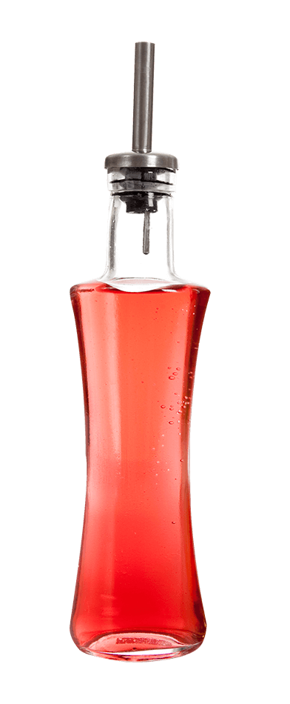 1 tablespoon red wine vinegar
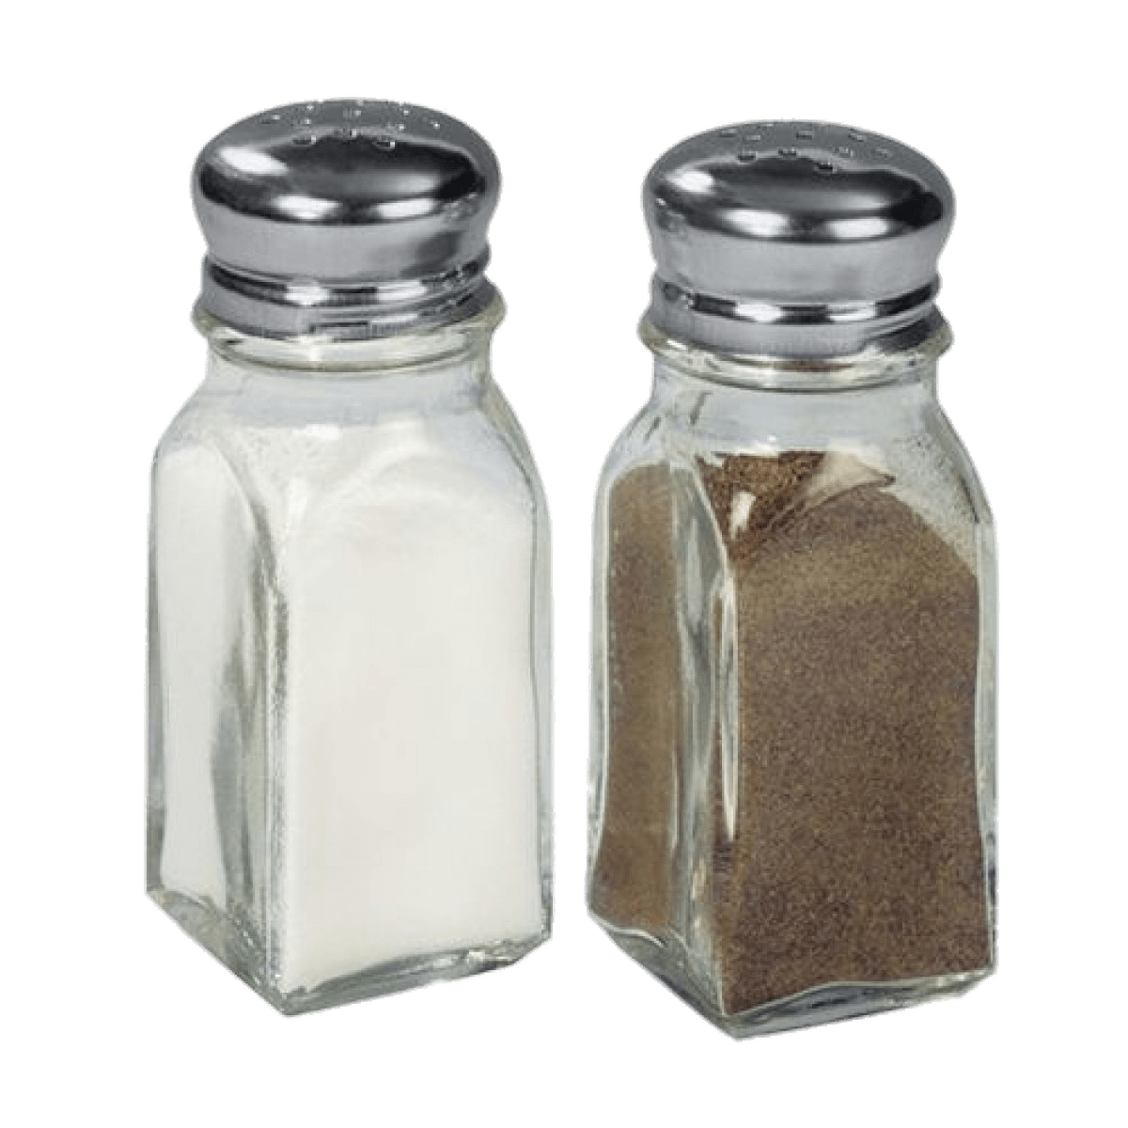 ¼ teaspoon salt
¼ teaspoon black pepper adjust to taste
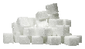 ¼ teaspoon sugar optional
Equipment:
- Cutting board
- Sharp knife
- Measuring cups
- Measuring spoons
- Large mixing bowl
- Small container
- Serving spoon

Fun Fact, Notes, Health Benefits, etc.:
- This crunchy corn salad is the perfect complement to your favorite BBQ dish.
- Olive oil is a healthy and tasty substitute for vegetable oil.
- Try the recipe with kidney beans for added protein.
1 – Gather | 2 - Combine
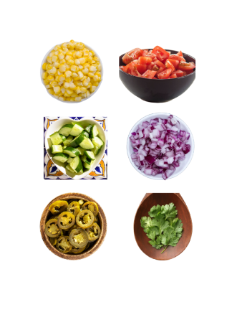 | 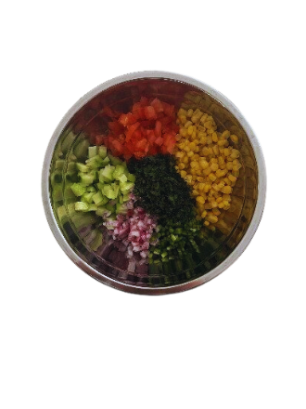
- Gather ingredients.  - Gather equipment. | - In a large mixing bowl, mix corn, tomatoes, cucumbers, jalapeno, & cilantro.
3 – Combine | 4 – Mix
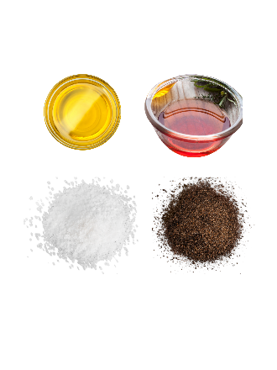 | 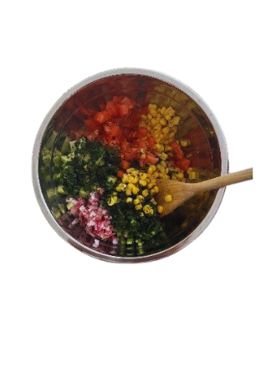
- In a small container, mix olive oil, vinegar, salt & pepper. | - Add liquids to corn mixture and stir to coat evenly.

5 – Serve
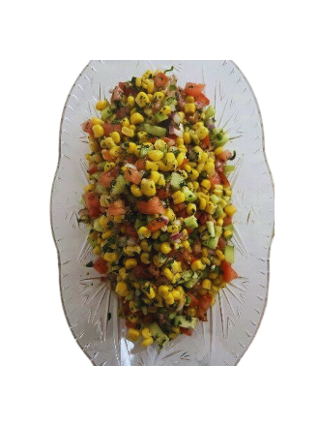
- Adjust seasonings.
- Serve & enjoy!

