Kale and Bean Soup
Servings 5

Ingredients:
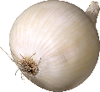 1 cup chopped onion
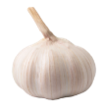 4 cloves garlic, minced or 1 teaspoon garlic powder
 1-2 Tablespoon margarine or butter
 2 cups low-sodium broth (any type)
 1 can (15 ounces) white beans, drained and rinsed
 1 ¾ cups or 1 can (14.5 ounces) diced tomato with juice
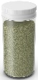 1 Tablespoon Italian seasoning
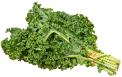 3 cups chopped fresh kale or 1 cup frozen chopped kale

Equipment:
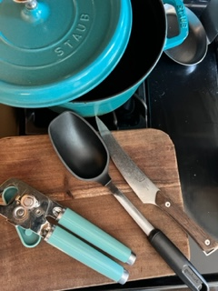
- Large sauce pot with lid
- Can opener
- Kitchen knife
- Cutting board
- Stirring spoon

Fun Fact, Notes, Health Benefits, etc.:
- Typically 1 bunch fresh kale equals about 8 cups, chopped. Be sure to destem your kale before using in the soup, you don’t have to throw away stems they are useful in soups and stocks.
- You can cook your own dry beans, just be sure to prepare/soak beans overnight if needed and include extra time to cook the beans in your prep. One can (15 ounces) is about 1 1/2 to 1 3/4 cups drained beans.
1 – Gather | 2 – Sauté
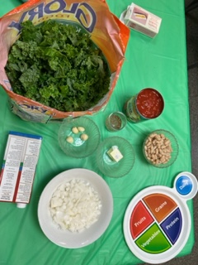 | 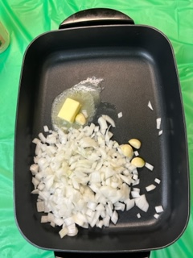
- Gather your ingredients. | - In a Saucepan over medium-high heat, sauté onion and garlic in margarine or butter until soft.
3 – Sauté | 4 – Add and mix ingredients
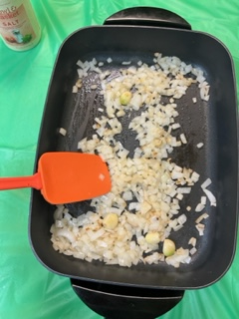 | 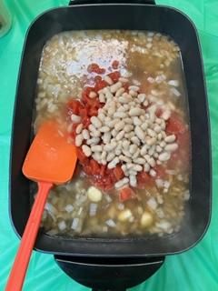
- Cook onions and garlic until soft, 3-5 minutes. | - Add broth, white beans and tomatoes; stir to combine.
5 – Boil | 6 - Simmer
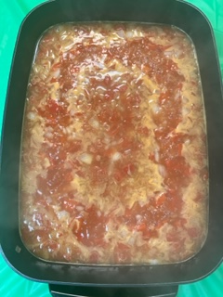 | 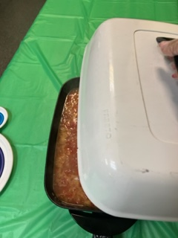
- Bring to a boil. | - Reduce heat to low, cover, and simmer for about 5 minutes.
7 – Add seasoning | 8 – Add kale
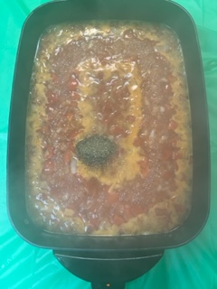 | 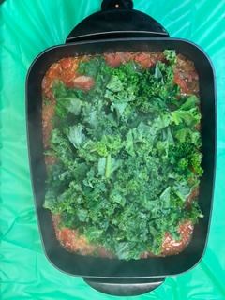
- Add Italian seasoning. | - Add kale.
9 – Simmer | 10 – Enjoy!
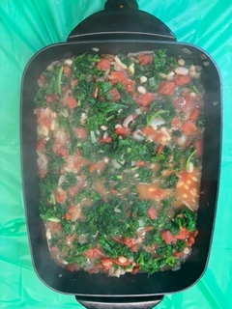 | 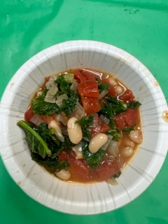
- Simmer until kale has softened, 3-5 minutes. | - Serve warm.

