NJ SNAP-Ed XL Recipe Cards: Kale and Cranberry Stir-Fry
Ingredients:
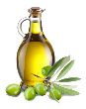 1 teaspoon vegetable oil
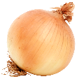 ¼ cup chopped onion ( ¼ medium onion)
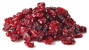 ¼ cup dried cranberries
1 clove garlic, minced or ¼ teaspoon garlic powder
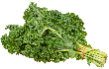 6 cups chopped kale (leaf portion, no stems)
 Juice from ½ orange (1/4 cup)

Equipment:
- Skillet
- Cutting board
- Knife
- Spatula
- Measuring cups

Fun Fact, Notes, Health Benefits, etc.:

- Kale is a superfood! The dark leafy greens carry a high amount of vitamin K, folate and fiber that make it a very nutrient dense food to eat! A fun fact about kale is that it is mostly available all year because it can grow fairly well in colder months. Kale can be easily incorporated in meals by adding it to stir-fry pastas, smoothies, and soups. You can even roast them to make kale chips...the possibilities are endless! These are all easy ways to add your greens in, like this soup recipe with kale and white beans. Try it today!

- Ingredients | 2 – Step one Sauté Onions
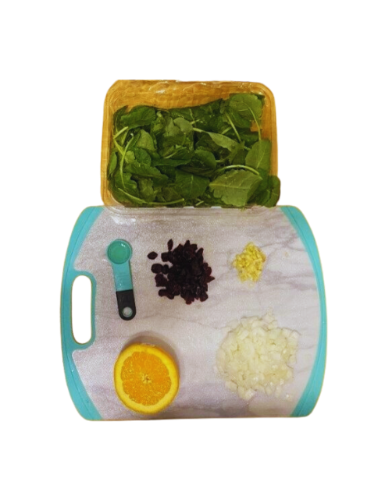 | 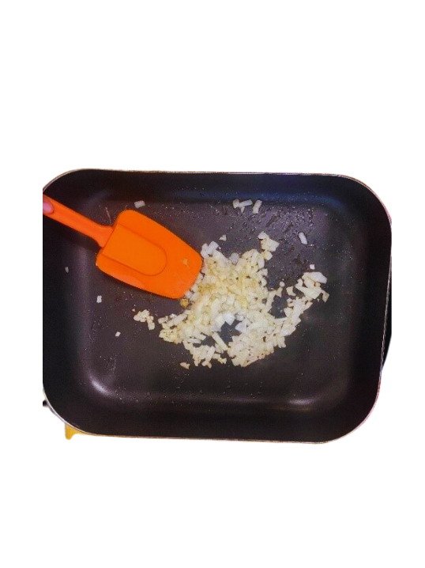
- Gather Ingredients and Equipment. | - In a skillet at 350 degrees Fahrenheit combine 1 teaspoon of vegetable oil and ¼ cup chopped onions. Sauté until onions are clear.
3 – Add Dried Cranberries and Garlic | 4 – Add Kale and Orange Juice
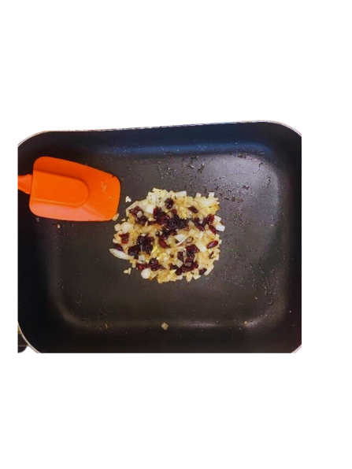 | 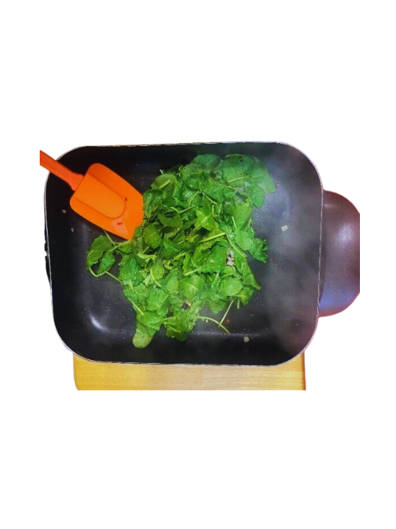
- Add cranberries and garlic to the onions. Continue to sauté for 2-3 minutes. | - Add kale, pour or squeeze orange juice over top of kale. Continue to stir fry for about 5 minutes until kale is wilting and hot.

5 –Cook Kale | 6 -Serve Kale Stir Fry
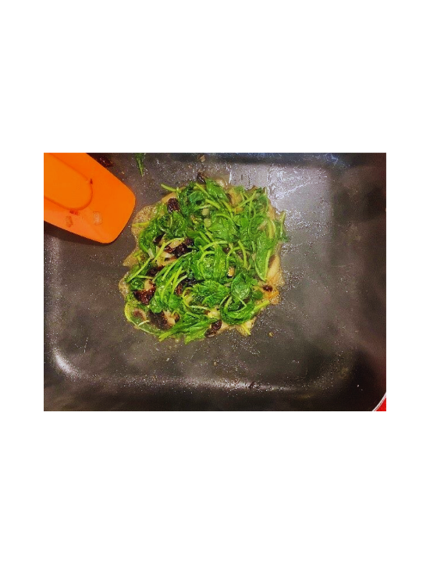 | 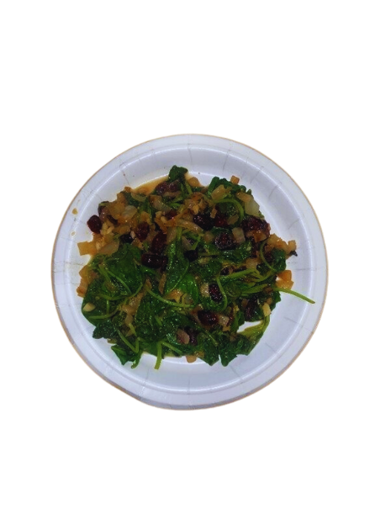
- Once kale is hot and wilted serve immediately. | - Enjoy, remember to refrigerate leftovers within 2 hours.

