NJ SNAP-Ed XL Recipe Cards – Potato Corn Soup
Serving Size - 5
Ingredients:

1 tablespoon oil
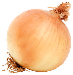1 cup chopped onions
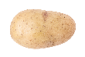 3 cups diced potatoes
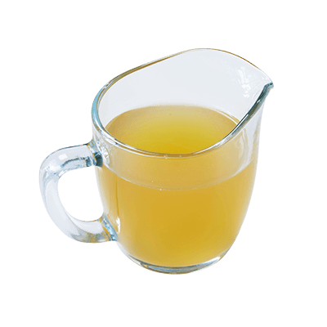2 cups low sodium broth
 1 cup low fat milk
 1.5 cups corn
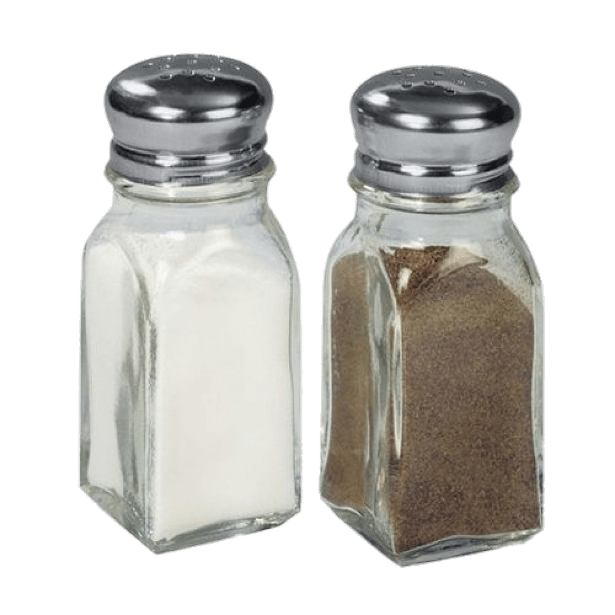salt and pepper to taste

Equipment:
- Measuring cups
- Cutting board
- Spatula
- Large pot
- Sharp knife
- Serving spoon

Fun Fact, Notes, Health Benefits, etc.:
- Corn is high in insoluble fiber which aids in digestion. Not only is corn packed with fiber it also contains a lot of other valuable nutrients such as Vitamins A & C, Calcium, Folate, Potassium, and Magnesium. Corn being packed with all these nutrients makes it good for not only gut health but also eyesight, and it only moderately affects blood sugar.
- While potatoes may have a bad reputation because of the high starch content found in them, they can actually be quite good for you depending on the meal you prepare it with. Potatoes contain no fat, cholesterol, or sodium naturally; They are naturally a low-calorie food. Some nutrients that are high in potatoes are Vitamin C, Vitamin B6, and Potassium. Potatoes contain carbohydrates which are a good source of energy for the body.

1 –Gather | 2 – Sauté Onions
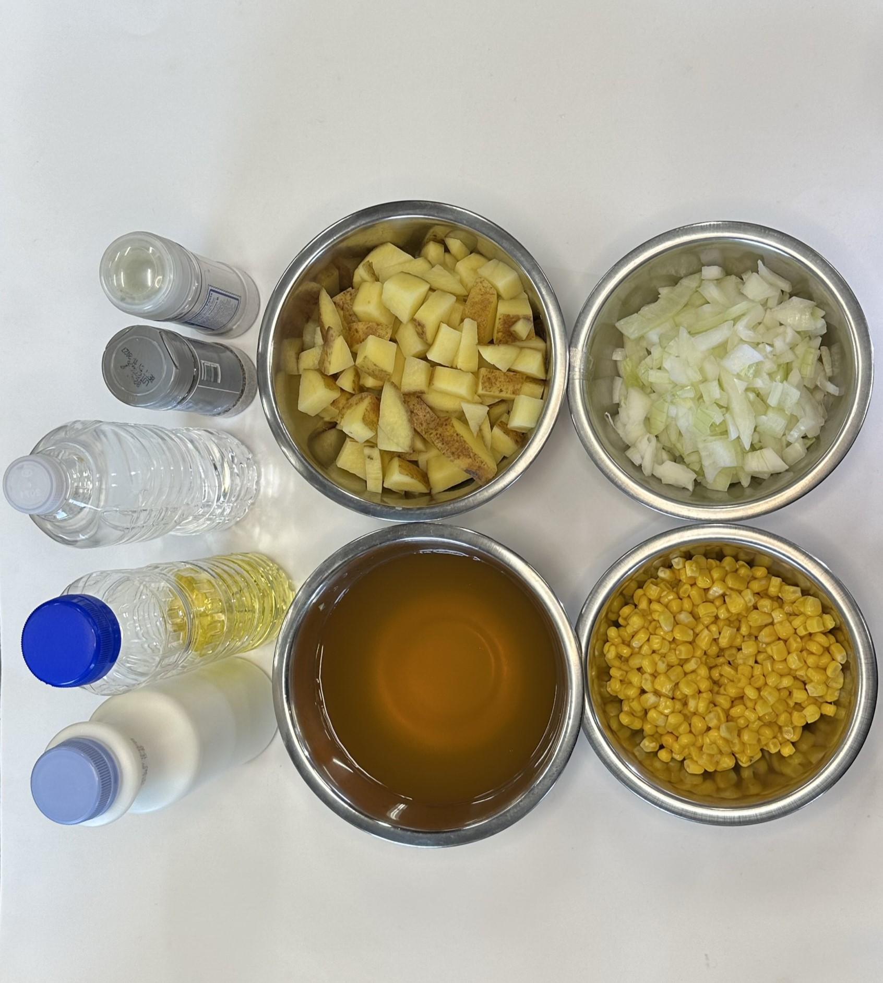 | 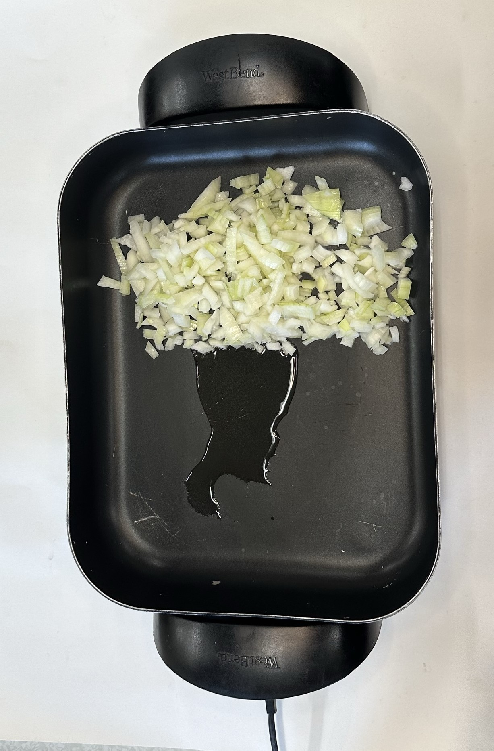
- Gather ingredients and equipment | - In a large pot, heat oil over medium heat  - Add onions and cook until soft
3 – Add Potatoes | 4 – Stir until Smooth
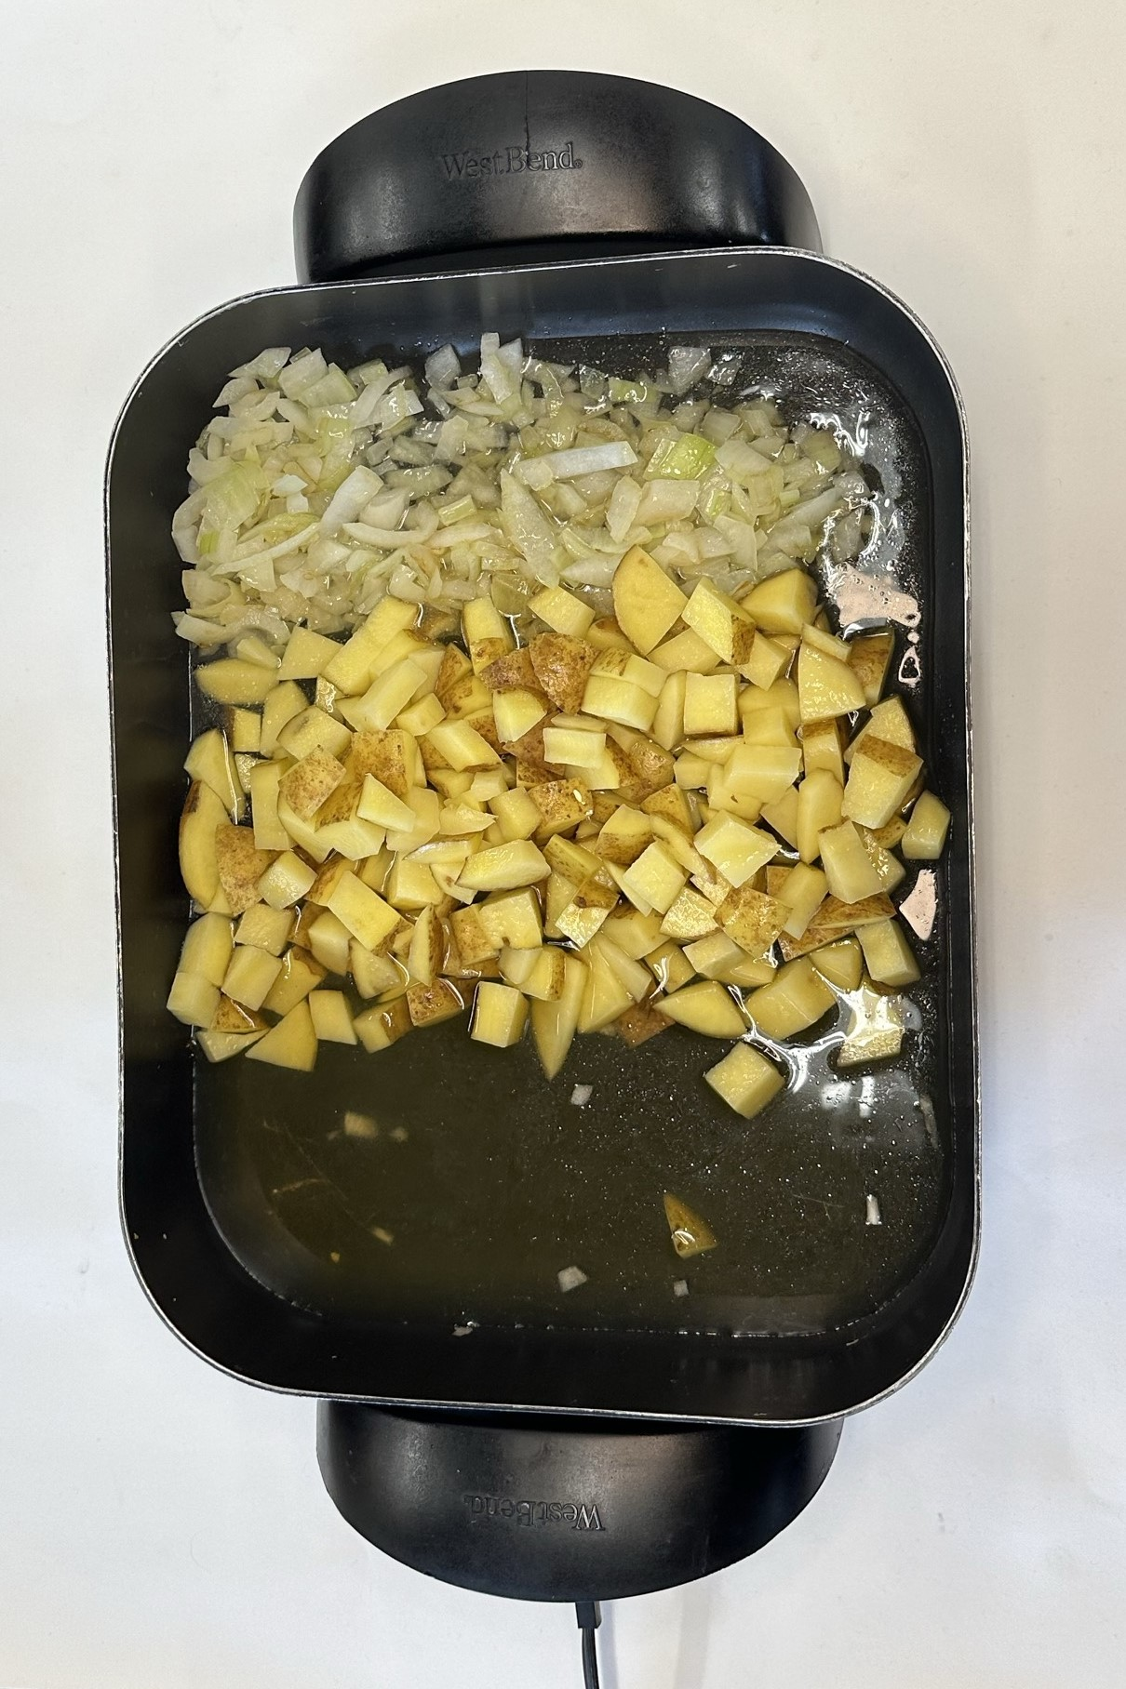 | 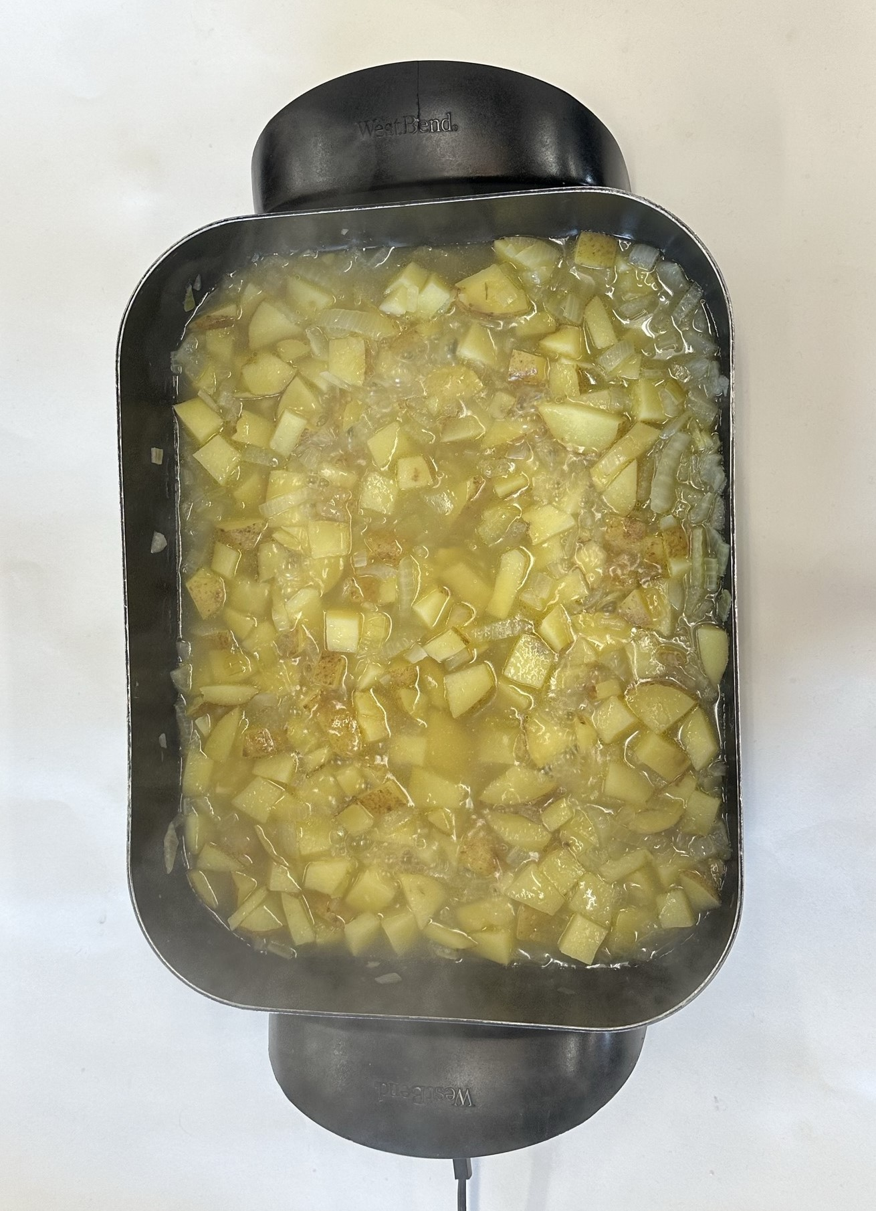
- Add Potatoes, broth, and 1 cup of water  - Bring to a boil  - Lower heat and simmer for 30 minutes | - Stir until smooth  - Use the back of a spoon or fork to mash some of the potatoes

5 – Add Milk and Corn | 6 – Serve Hot
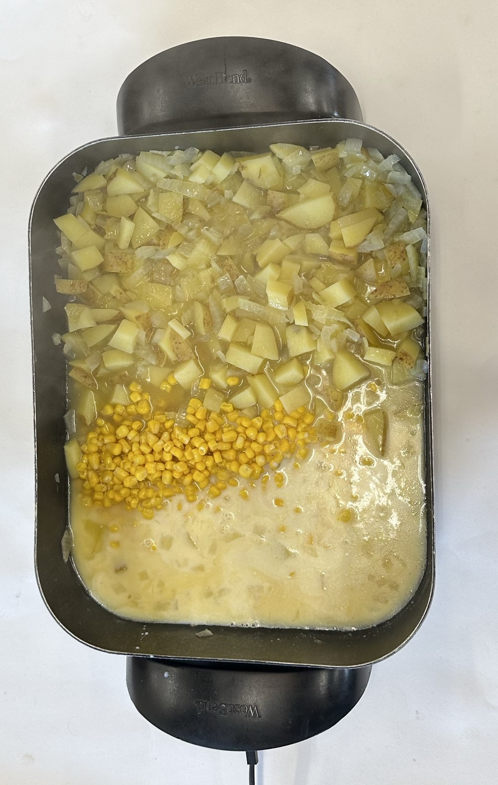 | 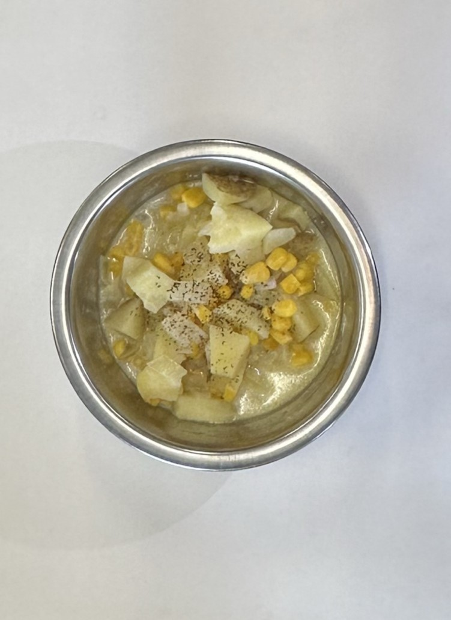
- Add milk and corn  - Reheat on medium heat for 10 minutes | - Serve hot and enjoy  - Add salt and pepper to taste  - Refrigerate leftovers within 2 hours

