NJ SNAP-Ed XL Recipe Cards – Three Sisters Soup
Serving Size – 8 cups
Prep Time – 15 minutes
Cook Time - 30 minutes
Ingredients:
 1 ½ tablespoons vegetable oil
 ¾ cup diced carrot
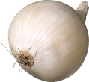 1 cup chopped onion
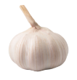 4 cloves garlic, minced or 1 teaspoon garlic powder
  2 cups diced squash (summer or winter, fresh or frozen)
 1 ½ cups corn (fresh or frozen) or a 15-ounce can (drained and rinsed)
 1 ½ cups cooked beans (any type) or a 15-ounce can (drained and rinsed)
 1 can (15 ounces) diced tomatoes, or 2 cups diced fresh
 3 ½ cups low-sodium broth (any type)
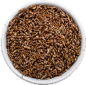 1 teaspoon cumin
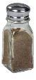 ¼ teaspoon pepper

Equipment:
- Measuring cups
- Measuring spoons
- Liquid measuring cup
- Cutting board
- Knife
- Large pot
- Mixing spoon

Fun Fact, Notes, Health Benefits, etc.:
- Change the vegetables and beans based on what you have on hand. Change the vegetables and beans based on what you have available.
- Instead of cumin, try 2 to 3 teaspoons of Italian seasoning or 1 tablespoon of curry powder.
- Zucchini is referred to as a vegetable, but it is an actually a fruit. They range in color from dark emerald green to a yellowish shade and are rich in fiber which is great for digestion.

1 – Gather Ingredients | 2 - Sauté
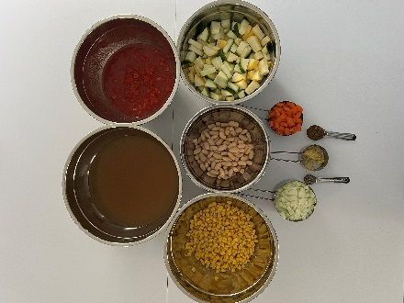 | 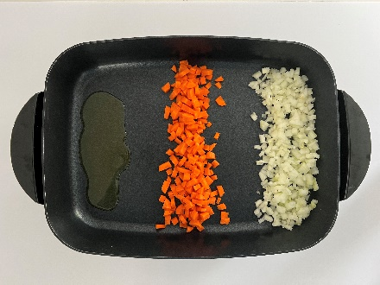
- Gather ingredients and equipment. | - Heat oil in a large pot on medium heat.  - Add carrot and onion and cook until onions begin to turn a little brown, about 8-10 minutes.
3 – Mix ingredients | 4 – Mix ingredients
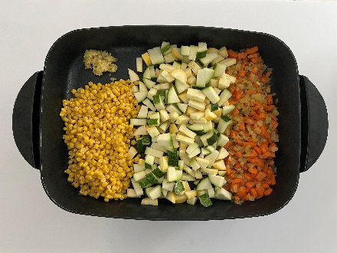 | 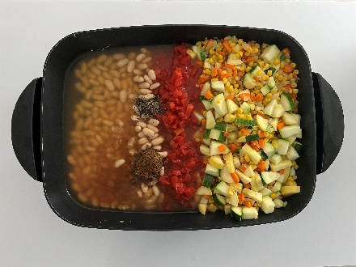
- Add garlic, squash, and corn and continue to stir for another 3-4 minutes. | - Add beans, tomatoes, broth, cumin, and pepper.

5 – Boil | 6 – Serve & Enjoy
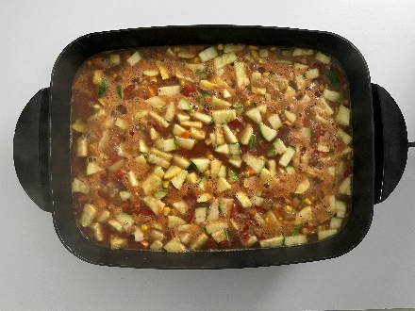 | 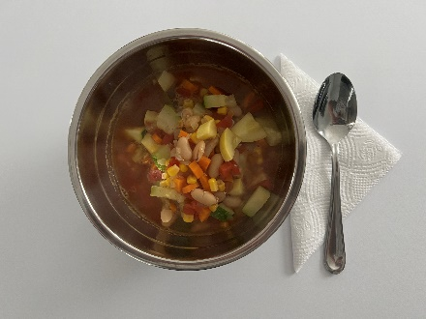
- Allow the soup to come to a boil.  - Turn heat down and simmer until all vegetables are tender to taste, about 15-30 minutes. | - Serve & enjoy!  - Refrigerate leftovers within 2 hours.

