Veggie Burger
Serving amount: 8
Ingredients:
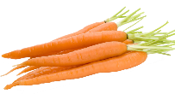 1 cup shredded carrots (1 to 1.5 carrots)
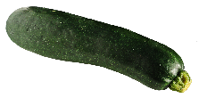 1 cup shredded zucchini
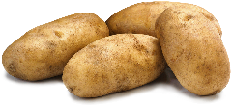 1 cup shredded potatoes
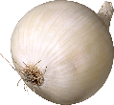 ½ cup thinly sliced onion
2 tablespoons chopped parsley
 2 eggs
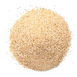 1 cup breadcrumbs
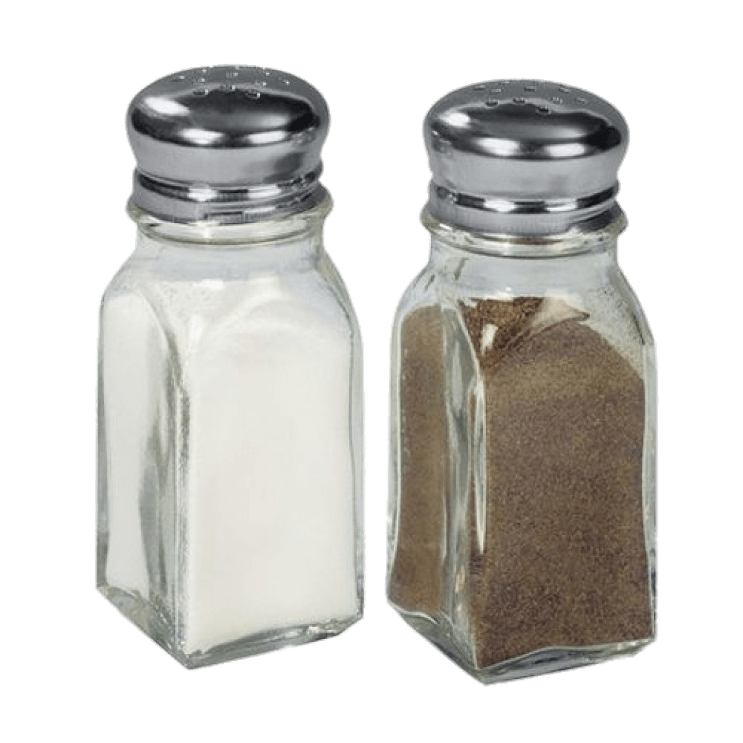 1 teaspoon salt
¼ teaspoon pepper
 1 tablespoon oil

Equipment:
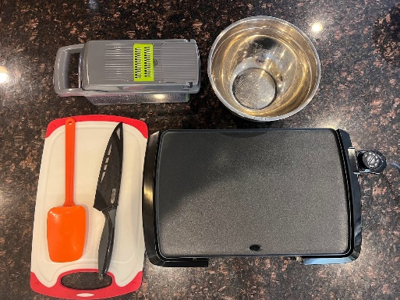
- Veggie shredder, cheese grater, veggie spiral, veggie peeler, or any tool to shred veggies
- Cutting Board
- Chefs Knife
- Spatula
- Bowl
- Skillet or stove top

Fun Fact, Notes, Health Benefits, etc.:
- If you don’t have a way to shred veggies, buy them pre-shredded in the frozen aisle.
- Add your favorite cheese (for example feta, cheddar, gouda, etc.) to add a serving of dairy to the recipe.
- Be careful when shredding veggies, use a knife safe glove for extra protection.
- Top with Greek yogurt for added protein. You can also enjoy your veggie burger on a bun.

1 – Prep | 2 – Measure
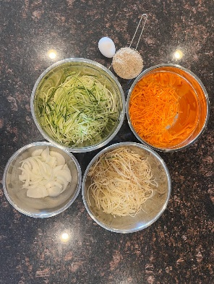 | 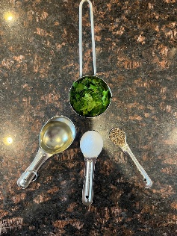
- Gather, shred, and chop ingredients. | - Measure out ingredients.
3 – Combined | 4 – Mix
 | 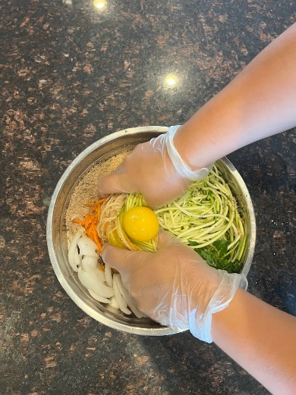
- Combined all ingredients except the oil, save that for the pan. | - Combined ingredients together in a bowl.

5 – Portion | 6 – Shape
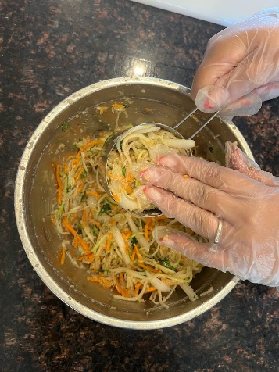 | 
- Portion out patties in a one cup measuring cup. | - Shape into burgers.
7 – Grease | 8 – Cook
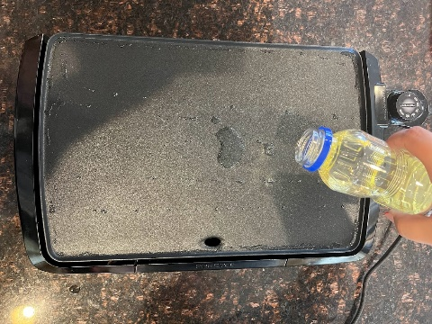 | 
- Heat up frying pan and grease right before cooking. | - Place patties on skillet, turn heat to medium high.

9 – Flip | 10 – Enjoy
 | 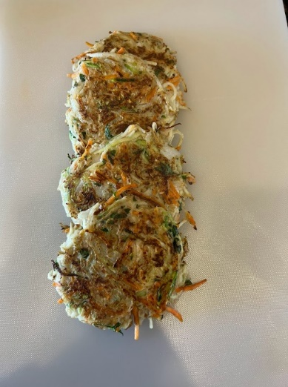
- Cook for 8 mins on each side and flip, cook until golden. | - Serve and enjoy!

